Living Organ Transplantation Policy Transition in Asia: towards Adaptive Policy Changes

Alex He Jingwei, Allen Lai Yu-Hung, and Leong Ching

Advances in medical science have opened up a new supply channel of organs for sick patients. But health policies to match supply to demand, in particular the use of financial incentives for organ procurement, have been stymied largely at the formulation stage. This paper maps these policies in ten Asian economies along two defining variables: donor restriction and donor compensation. It finds substantial adaptive changes over the past two decades - half of these cases show a substantive change in either expanding donor eligibility, legalizing compensation, or both. The resulting analysis illuminates the need for a regulated liberalization of related policies and the establishment of regional governance perspectives.

Introduction

Patients at risk of death from organ failure are willing to pay for organs. Donors, who need money or other compensation for the medical risk of donating their organs, are willing to accept. Yet, or so it seems, never the twain shall meet. There is something in the nature of organ donation that makes the price mechanism—in the form of an open market— unpalatable to policymakers.
But the pent up demand for organs cannot be denied. In the United States alone, it was said that in 2006 alone, more than 6,000 patients in the waiting list—one person every 90 minutes—died while awaiting transplantation. Despite the steadily expanding donor pools worldwide, the number of donors has never kept pace with the rapidly increasing number of patients on the waiting list (Figure 1 for US case).
Cadaveric donors account for the majority of organ sources (more than 90 percent in China and the European Union), but this source is heavily constrained by the willingness of donation. Recent years have seen a steady increase of living donors (Figure 2 for the US case), bolstered in part by the medical profession’s consensus that this option provides an improved medical outcome over deceased-donor transplantation. Living donor kidney transplantation is taking on a more predominant role than ever. According to the Donor Nephrectomy Outcomes Research Network (DNORN), nearly 40 percent of all kidney transplants worldwide are derived from living donors.

Figure 1: Growing Numbers of Human Organ Donors, Patients in the Waiting List and Transplanted
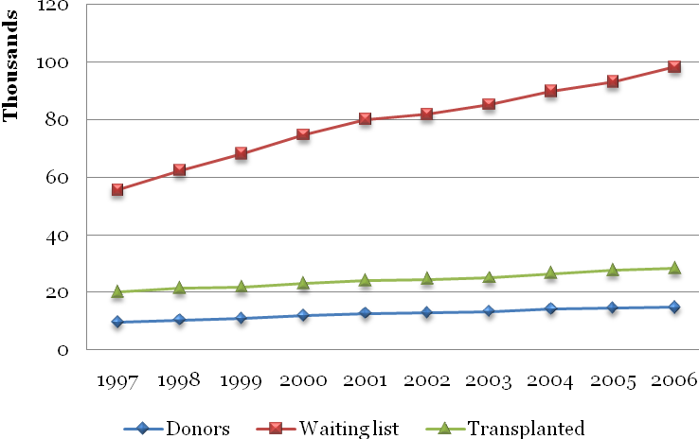

Source: Organ Procurement and Transplantation Network (OPTN) annual report, http://www.optn.org/latestData/step2.asp

Figure 2: Recovered Transplant Patients in the United States, by Donor Type
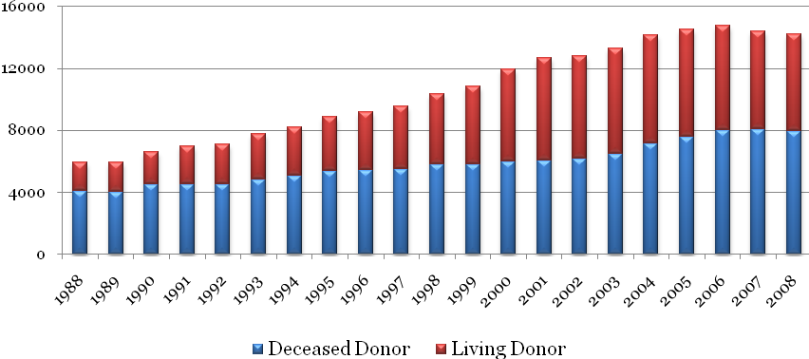

Source: Organ Procurement and Transplantation Network (OPTN) annual report, http://www.optn.org/latestData/step2.asp

Living donation however, brings its own challenge—the potential for organ trade. On one level, this is an ethical problem—banning the purchase of human organs from compensated donors will prevent exploitation of the poor. At the same time, it also denies the right to live to potential recipients, who will otherwise die without organ transplantation. As Gary Becker, the Nobel Prize Laureate, puts it, “when an economist sees a persistent gap between demand and supply—as in demand and supply of organs for transplants—he generally concludes that there are obstacles to equilibrating that market, and the obstacles are obvious in the market for transplants since (almost) no country allows monetary incentives to acquire organs either from living individuals or from cadaver.”
Taking off from this economic rationality, proposals aiming at eliminating this gap have been mooted—including the creation of a spot or future market for organs, where financial incentives are provided to potential donors. More modest proposals target compensation for donors, such as medical expenses and subsidies for earning lost. One common criticism of such matching of supply and demand is that it risks commodifying human organs. If an organ market is created, the fear is that it may not only offend religious and personal beliefs in the sanctity of the human body, but also changes the nature of altruism. More unacceptably, this would permit the rich to claim property rights over the bodies of the poor, eventually leading to a moral crisis.
In reply, pro-market activists have put forward the possibility of a controlled market. Indeed, the term “market” has been jettisoned in favor of something more innocuous, such as “introducing financial incentives.” The ethical arguments for and against financial incentives for organs appear fairly matched.
Gilnardo Novelli et al argue that organ selling is deeply rooted in poverty, and if the government is unable to guarantee the poor the basic necessity of life, it cannot ethically oppose the legalization of organ commerce. James Taylor contends that for people who respect personal autonomy and human well-being, allowing people to donate their organs and get compensation is not only morally permissible, but also imperative. Some further contend that attempts to protect the poor from exploitation by making organ sale illegal impose ethical values shaped by the affluent or more egalitarian societies and prevent the poor in developing nations from profiting from the resources available to them. And if the commerce of organs cannot be totally eliminated, regulated and managed organ sales would be an appropriate policy.
Even as this ethical debate continues, pragmatism has overtaken the realm of public policy—gradually, compensating living donors has evolved from a highly controversial and provocative issue, confined only to covert practice in developing countries, to one that is openly debated and implemented in richer countries too. In this regard, Asia has displayed dynamic pictures.
This paper surveys trends in ten Asian economies and highlights the gradual loosening of restrictions on donor eligibility and compensation. We suggest that one explanation for those cases which have remained unchanged in their transplantation policies is the existence of a thriving trans-boundary organ trade, which although ethically indefensible, is tolerated by pragmatic policymakers. This paper has two key contributions: first, it allows a general understanding of the policymaking process in difficult health policies. In particular, why do countries facing similar problems, formulating similar solutions, move at such vastly different speeds? Second, this paper analyzes the policy along two key variables—donor eligibility and donor compensation. Considering living organ transplants along these two lines have allowed us the first step towards building an analytically useful taxonomy of organ transplantation policies.

Policy Problem and Transition in Asia

The demand for organ transplant in Asia is immense; with China’s waiting list for organ transplants holding 1.5 million people, for example. However, partly due to cultural and educational reasons, the donation rates in Asia are disproportionately lower than those in their Western industrial counterparts. This has aggravated the organ shortage on the Asian continent (Figure 3). As a result, Asia is lagging behind in actual number of organ transplants, which contributes to an enormous unmet demand (Figure 4).

Figure 3: Donor Rates in Selected Economies
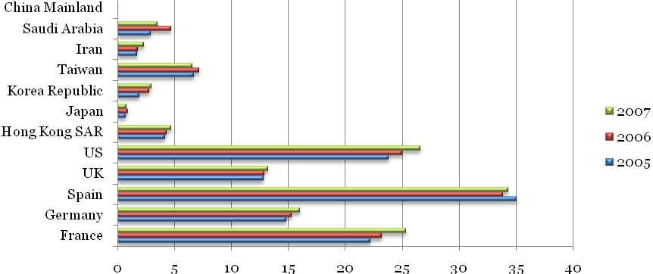
Unit: per million population
Sources: Mainland China’s data from http://health.sohu.com/s2008/donation/, the rest from http://www.doh.gov.tw/CHT2006

Figure 4: Transplantation of Organs in Different Continents in 2000
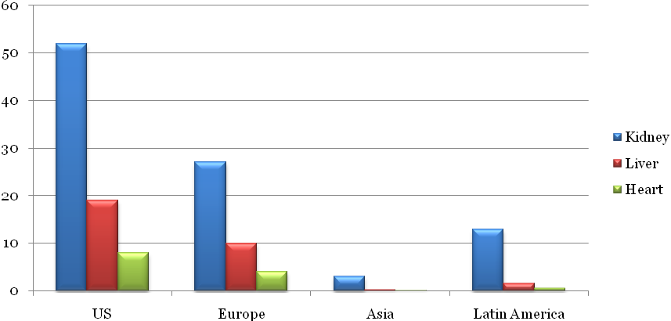
Source: R. Bhagwan Singh, “Indian police probe kidney sales by tsunami victims,” Reuters, January 16, 2007, available at http://www.reuters.com/article/healthNews/idUSDEL21432720070116; David J. Rothman, “Ethical and social consequences of selling a kidney,” JAMA 288, no. 13 (2 October 2002): 1640-1.

Organ transplantation in Asia is commonly considered a policy issue, rather than a clinical one. There has been an increasing tension between the official ban on organ trading and a ubiquitous black market. Aside from overt deals, pre-transplantation marriage-divorce arrangements, false allegations of family relationships are not uncommon in Asia. In India, “The Transplantation of Human Organs Act” of 1994 was enacted to regulate organ procurement and transplantation and to prohibit the sale of organs. But the situation of the “free market” did not change substantially and organ commerce is rampantly committed. In Pakistan, most poor donors have to accept the fact that half of the compensations will be taken by middlemen. A black market in organ trading has also long been flourishing in Mainland China, which specifically caters to medical transplant tourism from overseas, aside from its huge domestic demand. It is said that these patients mainly come from Japan, Korea, Hong Kong, and Taiwan. On the contrary, some Asian countries, Saudi Arabia and Iran as the most well-known, have embarked on a distinct path without much “exporting” domestic organ shortage abroad. They chose a pragmatic policy incentivizing potential living donors which leads to skyrocketed rates in living kidney donation.
The origin of living organ donation varies greatly in Asia. In China, more than 90 percent of the organ transplants are from executed prisoners. In Indonesia, only living donors are allowed; this is also the case in Iran, where the Islamic government outlaws the use of organs from the cadaveric for transplants because that is assumed to violate the Koran. In Hong Kong, Japan, Korea, the Philippines, Singapore, and Taiwan, both living and cadaveric donors are accepted. A differentiation between living-related and living-unrelated donors is of critical policy relevance, as it is believed living-related donors (usually family members) are motivated by altruism. Living-unrelated donation on the other hand, is thought to be driven by mixed motives, including that of financial gain.
Mainland China, Hong Kong, and Taiwan have adopted similarly conservative policies. Eligible donors are confined to the living-related. But the reality on the ground in Mainland China, especially, appears to be different. Even the Chinese Vice Health Minister admitted the existence of pseudo-relatives whose motives are simply money-oriented. In countries such as Japan, Saudi Arabia, and Korea, which have high household incomes and a fast-aging population, policymakers are less concerned about organ trading. In contrast, the Philippines, although it has roughly similar regulations, has seen rampant organ trade involving mainly foreign patients. This suggests merely sharing similar definitions of eligible living donors does not override each country’s unique policy context.
Another defining variable to mark divergent policies is donor compensation. Many countries have held fast to the notion that non-compensation underlines the altruistic nature of human organ donation and minimizes organ trading. Yet, pressed by soaring organ demand, some Asian economies, particularly those affluent ones, have relaxed their policies to admit some form of compensation. Therefore the landscape of living organ transplantation policies in Asia is changing.
The foregoing discussion has been to illustrate the point that while donor consent and brain death have been the central issues of cadaveric organ donation policies, donor restriction (eligibility) and donor compensation are the most crucial variables in defining living organ transplantation policies. Herein, we analyze the policy transition in ten Asian economies based on these twin variables (Table 1).

Table 1: Living Donor Transplantation Policies in Selected Economies by Donor Restriction and Compensation

Economy | Donor restriction |  |  |  | Donor compensation
Economy |  |  |  |  | Compensation
Economy | Living related |  |  | Living unrelated | Kidney | Liver
Economy | Immediate family | Close relatives | Emotionally attached | Living unrelated | Kidney | Liver
Mainland China | Yes | Yes | Yes | No | — | —
Hong Kong SAR | Yes | Yes | No | No | — | —
Iran | Yes | Yes | Yes | Yes | $2,000-4,000 | N/A
Japan | Yes | Yes | Yes | Yes | — | —
Korea | Yes | Yes | Yes | Yes | — | —
Malaysia | Yes | Yes | Yes | No | — | —
Philippines | Yes | Yes | Yes | Yes | — | —
Saudi Arabia | Yes | Yes | Yes | Yes | $13,3000& other benefits
Singapore | Yes | Yes | Yes | Yes | Still in discussion
Taiwan | Yes | Yes | No | No | — | —

Source: Authors’ database.

Easing Donor Restrictions: Mainland China & Taiwan

The case of Mainland China and Taiwan represent a cautious move in living organ transplantation policies. Although official compensation is still banned in these two sister economies, donor restrictions have been eased. Despite its impressive progress in human organ transplant technologies, China had no national policy governing living donor transplantation practices until 1995 when the “Human Organ Transplant Ordinance” was first enacted mainly by the Ministry of Health and under which human organ commerce is prohibited. The regulatory environment in China is relatively undeveloped, compared to medical progress, which has allowed de facto organ commerce to exist in China.
In March 2006, the Ministry of Health issued the “Interim Provision on Clinical Application and Management of Human Organ Transplantation,” symbolizing the government’s commitment to regulate this field. Not long after its enactment, the “Regulation on Human Organ Transplantation” was approved by the State Council and came into effect from May 1, 2007. Under the current regulatory regime, human organ commerce is strictly banned; violators are subject to fines and imprisonment. In donor eligibility, the original legislative proposal tended to confine it within 3rd degree consanguinity of the patient as well as spouse, but in the final regulation announced in 2007, donor eligibility was broadened to the so-called emotionally-attached individuals. This largely reflects the government’s eagerness to expand the organ sources to meet the huge demand. In order to minimize the possibility of organ commerce, the 2007 Regulation stipulates that no compensation should be incurred.
It was nine years later following the first organ transplant surgery that Taiwan promulgated “Human Organ Transplantation Act” (HOTA) in 1987, being the first in Asia to enforce laws regarding brain death. Living donor eligibility was first restricted within 3rd degree consanguinity and spouse. But in order to broaden the organ source, the donor eligibility was expanded to 5th consanguinity and spouse in an amendment enacted in 2002. However, organ donations still cannot meet domestic demand. As of 2008, the number of patients awaiting organ transplantation has reached 6,421, but each year there are merely around 100 donation cases.
Taiwan’s generous National Health Insurance Scheme covers most of the expenses incurred from organ transplantation. The law also stipulates that only those expenses incurred domestically can be reimbursed – but despite this, the majority of transplants are conducted off of the island. Faced with a domestic shortage of transplantable organs at home, many desperate Taiwanese patients continue their search on the other side of the Straits, even though they have to shoulder all of the costs. The actual volume of Taiwan-Mainland organ transplantation tourism is not known yet, but the data from the National Health Insurance Bureau shows half of these patients have their organs transplanted overseas, mainly in Mainland China. The expenses of one transplant vary from US $15,000 to 30,000.

Compensating Living Donors: Iran

A living unrelated donor program for renal transplantation was initiated in Iran as early as 1988. In the “Organ Transplantation Act” passed in 2000, living unrelated donors became legal. In 2006, Iran became the only country in Asia to legitimize free kidney sale and the market price is usually from $2,000 to $4,000. Before the promulgation of the new regulation, unrelated Iranian living kidney donors used to receive “a gift from the government” as a reward. The majority receive supplemental compensation, equivalent to US $1,550 from the recipients.This compensation system has resulted in a reduction in the rate of related living donation and limits expansion of cadaveric kidney transplantation, but is viewed as preventing uncontrolled commercial trade in organs. The new regulation provides stronger financial incentives for potential living donors. The Iranians call their model a “regulated market” and it has been seen as a solution to the increasing demand for organs. The immediate effect of this model is to boost Iran up to third place globally in living kidney donation rates.

Drastic Policy Transitions: Saudi Arabia & Singapore

Saudi Arabia and Singapore have been undergoing very drastic policy transitions in living organ transplantation. Restrictions in both donor eligibility and compensation have been relaxed significantly.
In Saudi Arabia, in its 1994 Regulation concerning living-related donation, stress was laid on documentation of the relationship between the donor and the recipient. The act of donation should be voluntary and the eligibility for donors was confined within consanguinities. It is worth emphasizing that living-unrelated transplantation was prohibited in Saudi Arabia at that time.
Yet, faced with severe shortage of organ sources, Saudi Arabia has changed its policy. According to the World Health Organization (WHO), a law passed in Saudi Arabia in October 2007 envisages that the government pays a monetary “reward” of 50,000 riyals (US$13,300) and other benefits, including life-time medical care, for unrelated organ donors in a system regulated at the national level. The law’s supporters said it would stop Saudi citizens from travelling to China, Egypt, Pakistan, the Philippines, and other countries to receive organ transplants. The effect of this new policy is immediate—Saudi Arabia quadrupled its rates of living kidney donation within a short period, ranking no. 1 today.
Singapore has faced a persistent shortage of organs for donations too. As of October 31, 2008, there were about 520 people on the kidney transplant waiting list. The average waiting time is nine years. Religious customs, cultural norms, and a fear of transplant operations have been cited as reasons for the donor shortage. Given its small population, and level of affluence, it is perhaps natural that this country will eventually find some ways to regulate this de facto market. The most recent of these has been an amendment to the “Human Organ Transplant Act” (HOTA) to allow compensation to donors. At the same time, it has also increased the penalty for organ trading, signaling that a complete price mechanism is unacceptable.
HOTA originally prohibits the giving or acceptance of organs under a “contract of arrangement” which precludes organ trading. In November 2008, the Ministry of Health (MOH) proposed that paired matching for exchange of organs be allowed in Singapore to increase the chances of improved transplant outcomes and to save more lives. Under this arrangement, patients can essentially switch donors. The MOH sees this as creating matches that may otherwise have not occurred, as well as others that are medically compatible for improved clinical outcomes.
A more radical change is to allow compensation to be made to living donors in Singapore. At the time of writing, this amendment has already been passed in the parliament, and the MOH is working out compensation levels. Under the law, provision is made for direct costs incurred as a result of the donation, as well as indirect losses such as lost earnings and future expenses due to the donation. In order to control the financial incentive, all the reimbursements will be credited to the donors’ medical savings accounts instead of cash transfers.

Policies Unchanged: Hong Kong SAR, Korea, Japan, Malaysia, & the Philippines

The policy governing living organ transplantation has changed little over the past decades in Hong Kong Special Administrative Region (SAR). The SAR government passed the “Human Organ Transplantation Ordinance” in 1998, and its amendment in the following year; living donors were restricted within consanguinities and spouses. In order to minimize the occurrence of pseudo-marriage for transplantation, it further stipulates that spouses from marriages that have lasted for less than three years are not considered as eligible living donors.
Living organ donation has had a long history in Japan. In fact, living donors account for a bigger share than cadaveric donors in the entire donor population, and 70 percent of kidney and all liver transplants are from living-related donors. Organ commerce is strictly prohibited in Japan and no monetary compensation is allowed. Although Japan accepts living-unrelated organ donors, supply is still far below demand, which has led to a flourishing organ transplant tourist trade with Mainland China.
In Korea, the major source of kidney donations was living-related donors (47.7 percent), followed by living-unrelated (34.0 percent) and cadaveric (18.3 percent) in 1997. More than 80 percent of organ transplants are performed using organs from living donors. Korea’s “Organ Transplantation Act” (OTA) was enacted in 1999 and has been in effect since 2000. Article Six of the OTA prohibits any real action and promise for organ trafficking, but living anonymous donation is allowed. Recently, providing financial incentives to potential living donors is proposed in Korea. A couple of provincial assemblies have already legalized financial compensation for the organ donors. These acts apparently contrast to the central government’s policy and the law and this has become an enormously controversial issue in Korea.
In Malaysia, living-related donors are defined as parents, siblings, or close relatives who are genetically related to the recipients, or spouses and very close friends who are “emotionally related” to the recipients. Living unrelated donors are also legal in Malaysia. The “Human Tissues Act” (HTA), enacted in 1974, is the first and only related statute in this country. The Act does not ban the purchase of organs and there is also no provision for any sanction in the event of a breach of any section. The Ministry of Health has therefore been trying to make amendments to the Act to prohibit commercial transactions and advertisements of human organs and tissues. There is presently no legislation governing the removal of organs from living donors. In the absence of any clear legal authority, it is presumed that living donations are legally permissible under valid consent obtained from the donor.
Ninety percent of kidney transplants in the Philippines are from living donors. Of the total living donors, 12 percent are from living unrelated donors, and this number has been increasing rapidly because of the rising demand and unavailability of organs coming from living-related donors and brain-dead cadavers. Following the legal definition, the living-related donors include 1st degree consanguinity—i.e. parents and children. However, considering the cultural and close kinship relationship in the country, this Order extends the definition of living related donors to siblings, cousins, nephews, nieces, and other blood relatives. Living-unrelated donations are permitted only on a voluntary basis. In 2002, the Department of Health (DOH) of the Philippines issued Administrative Order (AO) 124, which sets the guidelines for acceptance and management of organs from living (related and unrelated) donors and prohibits the sale and purchase of kidneys.

The Way Ahead: Towards Regulated Liberalization and Regional Governance

Asian countries face a double burden of a rising demand for transplantable organs coupled with low donation rates. This is compounded by the flourishing organ trade tourism from outside the region. Not surprisingly, the clinical consensus of the medical advantages of living organ transplantation has boosted the practice. In addition, what ethical and legal obstacles remain have not been able to suppress a booming black market in organ trading. To deal with this, some Asian countries have embarked on drastic reforms of their policies governing living organ donations, while some remain unchanged.
“Exporting” organ shortage has been a neglected reason for the slow adaptation of policies in affluent Asian economies, except Saudi Arabia and Singapore. Policymakers largely tolerate - if not encourage - their patients to search for organs abroad, which helps relieve domestic pressure on the one hand, but fuels trans-boundary organ commerce on the other. Aside from moral criticism, studies investigating health outcomes for recipients of purchased organs have revealed serious health problems with commercially acquired organs.
Evidence also shows that because purchasing an organ overseas may expose patients to an improperly-screened or incompetently-transplanted organ, many international recipients have returned home with HIV, viral hepatitis, tuberculosis, malaria, and other infections. Hence, making adaptive policy changes will go some way in ensuring the medical quality of the operations and subsequent care to their own patients. Therefore, a well-designed global—or regional as the first step—governance structure should be built to try to fill the huge gap between demand and supply in an ethical and healthy manner. Under this global/regional governance framework, a country should seek to resolve the organ shortage first by its own efforts without exporting it overseas.
Asian countries could take action at the regional level, learning from the Scandiatransplant program under which Denmark, Finland, Iceland, Norway, and Sweden share organ sources. This program has been very successful in providing organs for transplantation in the Scandinavian countries. Same models could be “transplanted” to Asian countries under existing regional governance frameworks such as the Association of South East Asian Nations (ASEAN). Political and cultural affinity and the common plight of organ shortage will enable the function of such regional arrangements, as shown from the Scandinavian experience.
At the national level, Iran, Saudi Arabia, and Singapore have shown remarkable adaptive capacity in policymaking. They chose to employ compensation, sometimes referred to as reimbursement or reward, as an instrument to lever the tension between demand and supply. The new policies’ efficacy and long-term implications should certainly be subject to more rigorous empirical investigations, but judging from donor rates alone, Iran and Saudi Arabia have outperformed other Asian countries within a short period.
These cases support the central proposal in this paper, i.e. given the severe shortage of organ sources and the limits of cadaveric donation, Asian economies need to enact substantial adaptive policy changes, which will contribute to global efforts in eradicating organ trade. Given the fact that donor restriction in most Asian economies studied in this research has been relaxed to include genetically-unrelated people, employing financial incentives becomes not only necessary but imperative.
One commonly cited reason in Asia for tolerating unregulated organ commerce is that of poverty alleviation. However, selling an organ often does not improve the living standard, based on the Asian experience. In Pakistan, for instance, the majority (93 percent) of those commercial living donors who sold a kidney to repay a debt and (85 percent) reported no economic improvement in their lives, as they were either still in debt or were unable to achieve their objectives in selling the kidney. Evidence from India also reveals that most commercial living donors do not experience long-term economic benefits or improved life circumstances after they sell a kidney. Indeed, what is consistently revealed is the deterioration of the health condition of the donors who sell their organs for cash. Even those countries which prohibit organ trade have largely failed to stop commercial dealings, with China and India as the most well-known examples. In this de facto marketplace, the disadvantaged donors would not be protected from potentially dangerous and unhealthy exploitation by unscrupulous brokers unless a regulated system is established.
When it comes to concrete proposals to undertake adaptive policy change towards regulated liberalization, Singapore’s experience is illustrative. Noting that there is a pool of potential organ donors who would be lured primarily by cash reimbursements, the Singaporean government has decided on the principle of non-withdrawability under the new regulatory regime. This means that the reimbursement, still undecided at the time of writing of this paper, may be considered generous, but it has to be channeled to the donor’s medical savings account, which cannot be withdrawn from in cash. This is expected to minimize the risk of organ commerce and benefit the donors’ health by allowing them to receive adequate post-transplant care. Such policy innovations could be considered by other countries with an interest in legalizing compensation, in light of their respective healthcare financing systems.

Conclusion

The world is facing a severe shortage of human organs. Despite numerous local and national educational campaigns and media promotions, the number of cadaveric donors has not increased. Meanwhile, there has been some progress in expanding the pool of living donors. The fear for fuelling organ trade has hindered global efforts in broadening organ pools from living donors. But the failure of a purely altruistic donation system in supplying the ever-increasing demand in recent decades gave rise to a reconsideration of other policy options.
This paper has developed a policy taxonomy based on two key variables in examining living organ transplantation policies, which are donor eligibility (or donor restriction) and donor compensation. We have found that half of the ten economies in our survey have undergone substantive changes in their policies, whereas the other half remains unchanged. Amongst them, Japan and Korea in particular have already regarded living-unrelated people as legitimate organ donors. But they seem unable to expand their organ pools further, given current demographics and cultural norms. This has pushed some Korean provinces to amend local regulations to legalize compensation to living organ donors. This was at first considered controversial but now seems irreversible. Taiwan, for its part, has made a minor amendment to its policy which extended donor eligibility.
In short, these economies do not appear to be adjusting their policies quickly enough to meet the demand, partly because of their level of affluence—patients can and in fact do engage in organ tourism in less developed countries. Mainland China has been the most popular destination.
This paper commends Singapore, Iran, and Saudi Arabia’s adaptive policy changes in incentivizing potential donors by compensation. In light of low donation rates in the Asian region and the reality of a sustained and elevated demand for transplantable organs, incentivizing potential donors by possible alternatives in the form of rewards and/or financial compensation to expand the donor pool appears to be a more tenable option in lieu of the total prohibition of organ compensation. The compensation must be fully regulated by government agencies. Singapore’s experience in linking the compensation to the donors’ medical savings accounts and setting the principle of non-withdrawability would be of value to policy learning. Policymakers in other Asian countries may consider the possibility of integrating their own healthcare financing systems with the compensative components of their living organ donation schemes. This will strengthen governments’ capacity in regulating stakeholders’ behaviors.
In addition, we argue that in order to resolve the problem of organ trading in Asia, rich countries need to fast track policy changes and reduce their tolerance of organ tourism to less-developed countries in the region. A well-designed regional governance framework needs to be put in place to coordinate individual national efforts in matching supply with demand.

Alex He Jingwei is a Ph.D. Candidate at the Lee Kuan Yew School of Public Policy, National University of Singapore. His research interests include comparative health policy reform and the Chinese public policy process.

Allen Lai Yu-Hung is a Ph.D. Candidate at the Lee Kuan Yew School of Public Policy, National University of Singapore. He is also a certified urological surgeon from Taiwan. His research interests are aid policy, development assistance for health, and disaster management.

Leong Ching is a Ph.D. Candidate at the Lee Kuan Yew School of Public Policy, National University of Singapore. Her research is in regulatory regimes and governance, with a focus on comparative studies involving Asia.

The authors would like to thank Ms. Hyunjin Han and Mr. Susumu Yamaguchi for their valuable assistance, and the anonymous reviewer for comments.

California Transplant Donor Network, Available at: http://www.ctdn.org/resources_public.php (accessed 14 November 2009).
Archil B. Chkhotua, Tirza Klein, Eti Shabtai, Alexander Yussim, Ezra Shaharabani, Shmariahu Lustiq, and Eytan Mor, “Kidney Transplantation from Living-unrelated Donors: Comparison of Outcome with Living-related and Cadaveric Transplants under Current Immunosuppressive Protocols,” Urology 62, no.6 (December 2003): 1002-1006.
Lucy Diane Horvat, SalimahZ. Shariff, and Amit X.Garg, “Global Trends in the Rates of Living Kidney Donation,” Kidney International 75, no. 10, (May 2009): 1088-1098.
Gary S. Becker & Julio Jorge Elias, “Introducing Incentives in the Market for Live and Cadaveric Organ Donors,” 2002. Available at: http://home.uchicago.edu/~gbecker/MarketforLiveandCadavericOrganDonations_Becker_Elias.pdf (accessed 5 November 2009).
Margaret M. Bryne and Peter A. Thompson, “A Positive Analysis of Financial Incentives for Cadaveric Organ Donation,” Journal of Health Economics 20, no.1 (January 2001): 69-83; Lloyd R. Cohen, “Increasing the Supply of Transplant Organs: the Virtues of a Futures Market,” George Washington Law Review 58, no. 1 (November 1989): 1-51; Henry Hansmann, “The Economics and Ethics of Markets for Human Organs,” Journal of Health Politics, Policy and Law 14, no. 1 (November 1989): 57-85.
A. H. Barnett and David L. Kaserman, “The Shortage of Organs for Transplantation: Exploring the Alternatives,” Issues in Law and Medicine 9, no.2 (Fall 1993): 117-137.
C. J. Dougherty, “Body Futures: the Case against Marketing Human Organs,” Health Prog 68, no. 5 (June 1987): 51-55; EU Commission, “Organ Donation and Transplantation Policy Options at EU Level (Consultation Document) ,” Brussels, 2006; Nancy Scheper-Hughes, “Living Kidney Donations: Controversies and Realities: Organs without Borders: Open Markets, Closed Systems and the Global Search for Living Donors,” Program and Abstract of the American Transplant Congress, Seattle 2005; Kirpal S. Chugh and Vivekanand Jha, “Commerce in Transplantation in Third World Countries,” Kidney International 49, no. 5 (May 1996): 1181-1186.
Giuseppi Novelli, Maria Rita Rossi, L. Poli, V. Moraito, S Ferretti, A. Bussotti, Francesco Nudo, G. Mennini, Fabio Antonellis, and P.B. Berloco, “Is Legalizing the Organ Market Possible?,” Transplantation Proceedings 39, no. 6 (July 2007): 1734-1745.
James Stacy Taylor, Stakes and Kidneys: Why Markets in Human Body Parts are Morally Imperative? (Burlington, VT: Ashgate Publishers, 2005).
Trupti Patel, “India Kidney Trade,” TEM Case Studies 5, No. 1, Case #240, 1996; E. A. Friedman and A. L. Friedman, “Payment for Donor Kidneys: Pros and Cons,” Kidney International 69, no. 6 (March 2006): 960-962.
Gill Walt and Lucy Gilson, “Reforming the Health Sector in Developing Countries: The Central Role of Policy Analysis,” Health Policy and Planning 9, no. 4 (December 1994): 353-370.
Jiefu Huang, “Ethical and Legislative Perspectives on Liver Transplantation in the People’s Republic of China,” Liver Transplantation 13, no. 2 (February 2007): 193-196.
Catherine Exley, “Attitudes and Beliefs within the Sikh Community Regarding Organ Donation: A Pilot Study,” Social Science & Medicine 43, no. 1 (July 1996): 23-28.
“WHO Says Organ Demand Outstrips Supply,” Associated Press, 30 March 2007.
Y. H. Chen, “Tens of Thousands of Foreigners Coming to China for Organ Transplantations: An Investigation,” Phoenix Weekly 5 (2006): 2-6.
Lucy Diane Horvat, Salimah Z. Shariff, and Amit X.Garg, “Global Trends in the Rates of Living Kidney Donation,” Kidney International 75 (February 2009): 1088-1098.
Jiefu Huang, “Ethical and Legislative Perspectives on Liver Transplantation in the People’s Republic of China,” Liver Transplantation 13, no. 2 (February 2007): 193-196.
Hiroshi Takagi, “Organ Transplantations in Japan and Asian Countries,” Transplantation Proceedings 29, no. 8 (December 1997): 3199-3202.
“Illegal Living Organ Transplants Rampant in Mainland China [zhongguo huoti qiguan yizhi, dixia maimai changjue],” Wenweipo [wenhuibao], 2 November 2008.
Lori Hartwell, “Global Organ Donation Policies around the World,” Contemporary Dialysis & Nephrology, 1999, cited at http://www.lorihartwell.com/GlobalOrganDOantionPolicies.pdf (accessed October 13, 2009); A. Bagheri, “Organ Transplantation Laws in Asian Countries: A Comparative Study,” Transplantation Proceedings 37 (2005): 4159-4162.
Jiefu Huang, Yilei Mao, and J. Michael Mills, “Government Policy and Organ Transplantation in China,” The Lancet 372, no. 9654 (December 2008): 1937-1938.
The regulator coined a special term to describe this relationship, i.e. certifiable emotional closeness between recipient and donor.
“Response to National Health Insurance Bureau released the "organ transplant survival statistics" to face transplantation medicine in Taiwan,” Available at: http://www.organ.org.tw/JRNL/050/050002.htm (accessed 5 May 2010).
A. Bagheri, “Organ Transplantation Laws in Asian Countries: A Comparative Study,” Transplantation Proceedings 37, no. 10 (December 2005): 4159-4162.
Behrooz Broumand, “Transplantation Activities in Iran,” Experimental and Clinical Transplantation 3, no. 1 (June 2005): 333-337.
B. Larijani, F. Zahedi, and E. Taheri, “Ethical and Legal Aspects of Organ Transplantation in Iran,” Transplantation Proceedings 36, no. 5 (June 2004): 1241-1244.
A. J. Ghods, “Changing Ethics in Renal Transplantation: Presentation of Iran Model,” Transplantation Proceedings 36, no. 1 (January 2004): 11-13.
Lucy Diane Horvat, Salimah Z. Shariff, and Amit X.Garg, “Global Trends in the Rates of Living Kidney Donation,” Kidney International 75, no. 10 (May 2009): 1088-1098.
Faissal A. M. Shaheen, “Organ Transplantation in the Kingdom of Saudi Arabia: New Strategies,” Saudi Journal of Kidney Diseases and Transplantation 5, no. 1 (January-March 1994): 3-5.
WHO, “Dilemma over Live-Donor Transplantation,” WHO Bulletin Vol. 85, No. 1 (2007).
Lucy Diane Horvat, Salimah Z. Shariff, and Amit X. Garg, “Global Trends in the Rates of Living Kidney Donation,” Kidney International 75, no. 10 (May 2009): 1088-1098.
H. Amemiya, “Current Status of Organ Transplantation in Japan,” Transplantation Proceedings 31, no. 5 (August 1999): 1990-1991; K. Yanaga et al, “Overseas Liver Transplantation for Japanese Patients,” Transplantation Proceedings 31, no 5 (August 1999): 1950-1952.
Kiil Park, “Current Status of Organ Transplantation in Korea,” Transplantation Proceedings 31, no. 5 (August 1999): 1985-1986.
J. M. Chua et al, “The Ethics and Law on Organ Transplantation in Malaysia,” NCM Malaysia 3, no. 1 (January 2004): 2-5.
Administrative Order, No. 124S, 2002, National Policy on Kidney Transplantation from Living NonRelated Donors.
G.V. Prasad, Ashutosh Shukla, Michael Huang, R. John Honey, and Jeffrey Zaltzman, “Outcomes of Commercial Renal Transplantation: A Canadian Experience,” Transplantation 82, no. 9 (November 2006): 1130-1135; M. Canales, B. Kasiske, and M. Rosenberg, “Transplant Tourism: Outcomes of the United States Residents Who Undergo Kidney Transplantation Overseas,” Transplantation 82, no. 12 (December 2006): 1658-1661.
Sean Kennedy, Yvonne Shen, John A. Charlesworth, James D. Mackie, John D. Mahony, John J.P. Kelly, and Bruce A. Pussell, “Outcome of Overseas Commercial Kidney Transplantation: An Australian Perspective,” Medical Journal of Australia 182, no. 5 (March 2005): 224-227.
L. A. Lehtonen, “The Bioethics Convention of the Council of Europe and Organ Sharing for Transplant Recipients in Scandinavia,” Medical Law 21, no. 4 (January 2002): 744-747.
D. A. Budiani-Saberi and F. L. Delmonico, “Organ Trafficking and Transplant Tourism: A Commentary on the Global Realities,” American Journal of Transplantation 8, no. 5 (May 2008): 925-929.
M. Goyal M, R. Meheha, L. Schneiderman, and A. Sehgal, “Economic and Health Consequences of Selling a Kidney in India,” Journal of American Medical Association 288, no. 13 (October 2002): 1589-1593.
Debra Budiani, “Consequences of Living Kidney Donors in Egypt,” Presentation at the Middle East Society on Organ Transplants Meeting, November 2006 Kuwait; M. Goyal, R. Meheha, L. Schneiderman, A. Sehgal, “Economic and Health Consequences of Selling a Kidney in India,” Journal of American Medical Association 288, no. 13 (October 2002):1589-1593; Javaad Zargooshi, “Iranian Kidney Donors: Motivations and Relations with Recipients,” Journal of Urology 165, no.2 (February 2001): 386-92.

